Doc. Number: [Satellite Name]-AD-01
*Notice:
This file is an example based on generic satellite design and does not guarantee to be approved on the review process for launch or deployment. In accordance with design of each satellite, this document may have to be changed. Details of this template are subject to change without notice. Please change YELLOW sentence according to each satellite.
(本文書は標準的な設計の衛星を想定した一例であり、打上げ・放出のための審査プロセスでの承認を保証しているものではありません。各衛星の設計によって内容を変更する必要があります。また、本テンプレートの内容は予告なく変更される場合があります。黄色の箇所を各衛星に応じて変更してください。)

[Satellite Name]
FM Assembly Drawing

Revision History

Version | Date | Writer | Annotations
1 | DD/MM/YYYY | XXX | Initial Release
1.1
1.2

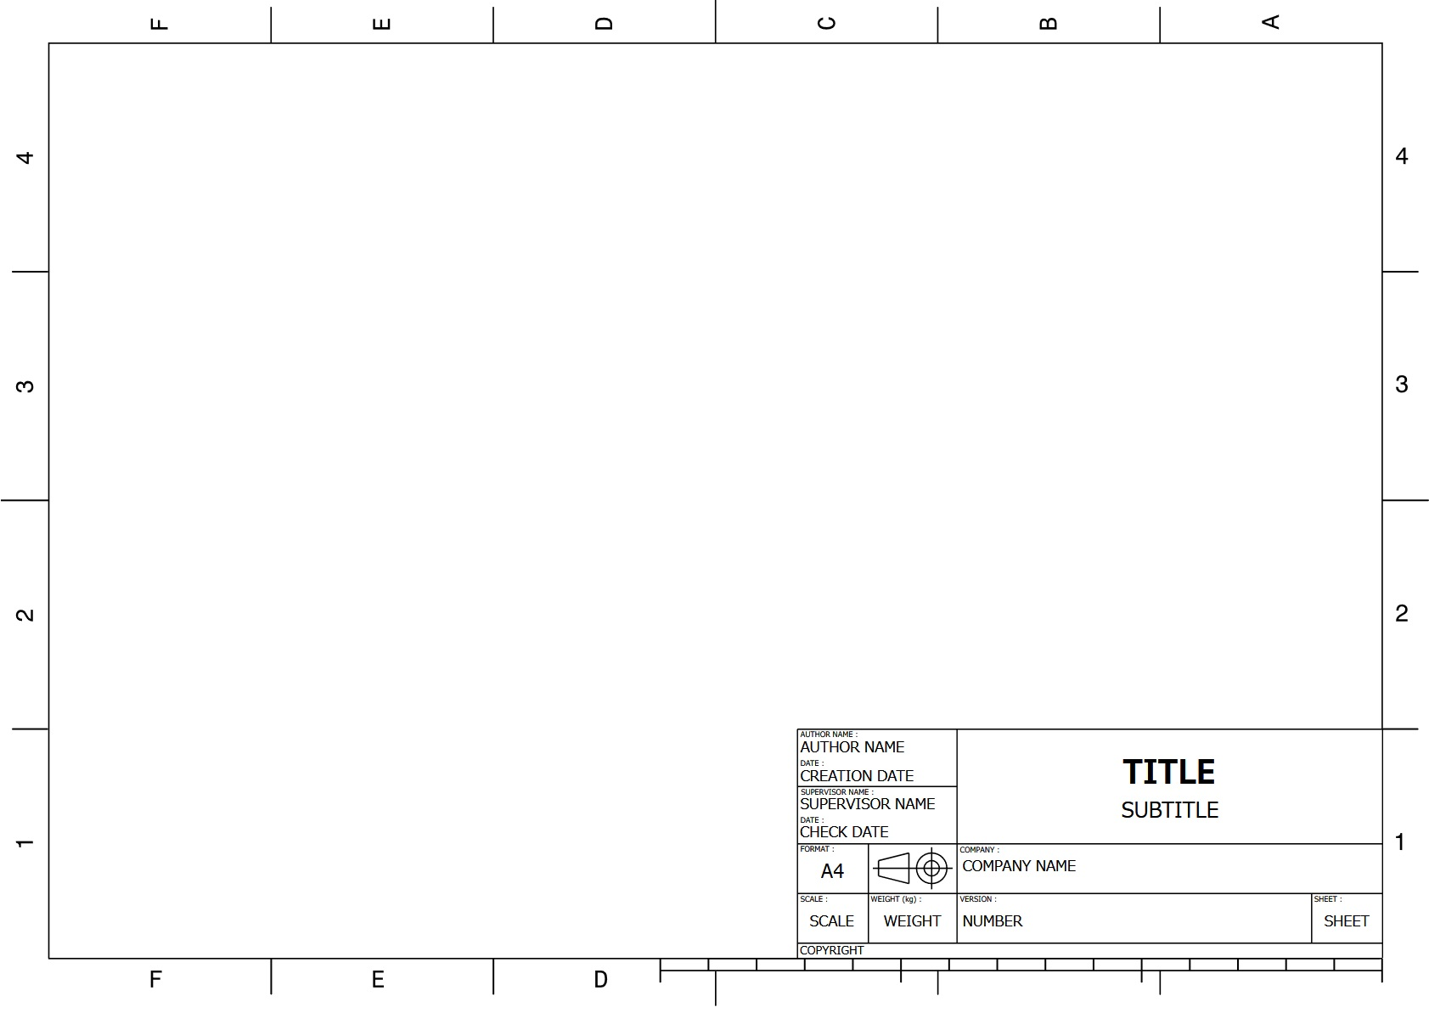
Instruction:
- Configuration before deployment and after deployment if configuration will be changed
- Need information where main parts such as antenna, solar panels or mission equipment are located
- Add coordinate system
- Delete this instruction when this drawing will be submitted.
Camera
Solar Panel
Bird’s-eye view
Sid
Top View
Bottom View
Side View
Instruction:
- Configuration before deployment inside J-SSOD
- Need all dimension, surface treatment spec, roughness, roundness and so on to verify handbook (JPAH vol.8)
- External dimension only
- Add coordinate system
- Confirm “Interface Verification Record” to check verified value prior to write this drawing
- Delete this instruction when this drawing will be submitted.
Instruction:
- Configuration AFTER deployment (antenna, panel or so on) if configuration will be changed.
- External dimension only
- Add all dimensions (length, width, thickness) of antenna and the other deployed parts
- Add dimension of antenna (length, width, thickness)
- Add coordinate system
- Delete this instruction when this drawing will be submitted.
Top View

Bottom View

Side View

