*Notice:
This file is an example based on generic satellite design and does not guarantee to be approved on the review process for launch or deployment. In accordance with design of each satellite, this document may have to be changed. Details of this template are subject to change without notice. Please change YELLOW sentence according to each satellite.
(本文書は標準的な設計の衛星を想定した一例であり、打上げ・放出のための審査プロセスでの承認を保証しているものではありません。各衛星の設計によって内容を変更する必要があります。また、本テンプレートの内容は予告なく変更される場合があります。黄色の箇所を各衛星に応じて変更してください。)

[Satellite Name]
Structural Analysis Report

Rev. NC: DD/MM/YYYY

[Project Team Name]

Revision History

Version | Date | Writer | Annotations
NC | DD/MM/YYYY | XXX | Initial Release
A
B

Contents

1. Purpose 1
2. Applicable Document 1
3. Abbreviation and Acronyms 2
4. Structural Design 2
5. Analysis Model 11
5.1. Mass Characteristic 11
5.2. Ballistic Number 11
5.3. Finite Element Modelling (FEM) 11
6. Analysis Result 13
6.1. Natural Frequency Analysis 13
6.2. Static Load Analysis 15
6.3. Bolt Analysis 18
7. Structure Fracture Control 21
7.1. Potentially Fracture Critical Parts Identification 21
7.1.1. Contained Parts 21
7.1.2. Fail-Safe Parts 21
7.1.3. Low Risk Fracture Parts 21
7.1.4. Sealed Container 21
7.1.5. Fracture Critical Parts 21
7.1.6. Pressurized System 21
7.1.7. Pressure Vessel 21
7.1.8. High-Energy Rotating Machineries 22
7.2. Inspection for Safety Critical Structures 22
7.3. Inspection after Tests 22
8. Discrepancy or Anomaly Reports 22
9. Material Usage Agreements for Stress Corrosion Cracking Material 22
10. Conclusions 22

Purpose
This document summarizes the results structural analysis and fracture control for [Satellite Name] which will be deployed from JEM Small Satellites Orbital Deployer(J-SSOD).

Notice:
This document is an example based on the following general satellite design. Note that an additional evaluation is required if a satellite has unique structural design. （本文書は主に下記に示すような標準的な衛星を想定している。これに当てはまらない衛星に関しては個別評価が追加されるため注意すること。）

- Main structure is made of metallic material（主構造が金属製）
- Simple structure design（単純な構造設計）
- No fracture critical part（フラクチャークリティカル部品がない）
- No sealed container or pressure system/vessel（シールドコンテナ、圧力系がない）
- Simple deployable mechanism（展開構造が単純）
- No glass except camera lens and solar panel （カメラレンズと太陽電池パネル以外にガラスが使われていない）

Applicable Document
- JX-ESPC-101132-C JEM Payload Accommodation Handbook-Vol.8-
Small Satellite Deployment Interface Control Document
Section 2.1. Mechanical Interfaces
2.1.5. Mass Properties
2.1.6. Separation Spring
2.1.8. Structural Strength
2.1.9. Stiffness
Section 2.4. Environmental Requirements
2.4.1. Random Vibration and Acceleration
2.4.2. On-orbit Acceleration
2.4.3. Pressure Environment
2.4.4. Thermal Environment

- JMX-2011303E Structure Verification and Fracture Control Plan
for JAXA Selected Small Satellite Released from J-SSOD
Section 6 Fracture Control Plan
Section 7 Structure Verification Plan
7.1. Analysis (applied to the satellite main structure)
7.2 Strength tests

Abbreviation and Acronyms

CAD Computer Aided Design
COTS Commercial Off-The-shelf
FEA Finite Element Analysis
FEM Finite Element Method
FS Factor of Safety
ISS International Space Station
J-SSOD JEM Small Satellite Orbital Deployer
JEM Japanese Experiment Module
MIUL Materials Identification Usage List
MS Margin of Safety
MUA Material Usage Agreement
NASA National Aeronautics and Space Administration
SAR Safety Assessment Report

Structural Design
Notice:
This sentence is example. Please describe about your own satellite （こちらの文章は例文です。個々の衛星の説明に書き換えてください）
[Satellite Name] is a 1U CubeSat whose dimension is XXXmm × XXXmm × XXXmm, and mass is XXXg. The satellite consists of an upper panel (one), side panels (four) and a bottom panel (one) that are mounted to structure main frame. [please describe the detailed of satellite structure not only outer side but also internal side. Please include the information about the material] M2.5 bolt will be used for constraining structure main frame and constraining external frame with each panel. Also, the satellite has an antenna deployable mechanism.
Figures 4-1 shows structural analysis model of [Satellite Name], and Figure 4-2 shows internal structure, and Figure 4-3 shows assembly diagram. Table 4-1 shows parts of [Satellite Name] for structure analysis and fracture control.

Notice:
SFCB will confirm how structure is configured in the beginning. Please describe explanation and image of satellite with considering the following points（SFCBは最初に構造がどのような構成になっているか確認します。下記を考慮して説明文や図表を記載してください）

- What kind of part the satellite consists of? And which part is located primary load path? How each part is fastened? （衛星は何の部品で構成されているか？どの部品が1次構造となっているか？どのように部品が締結されているか？）
- Does the satellite have safety critical parts, such as glass or rotating device, that identified on Fracture Control Evaluation Form? And where are they located? （衛星はガラスや回転体などの部品を持っているか？それは衛星内のどこにあるか？）
- Parts that are dynamically moved such as deploying antenna should be described. How are they fastened in the J-SSOD? How are they moved after deployment from J-SSOD? Is anything exposed after moving the mechanism? （展開アンテナ等の動きのあるものは記載しなければいけません。それらはJ-SSOD内でどのように固定されているか？放出後にどのようにそれらは動くか？動いた後、何かが露出するか？）

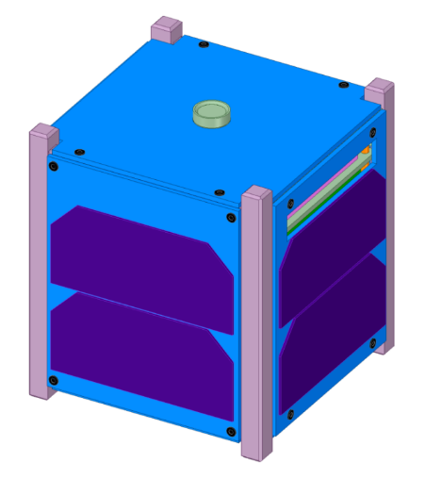
Camera
Solar Cell
Deployment Mechanism is inside of the +Z panel
Z
X
Y
Example
- This model is not simplified, but it shows all parts.
- Coordinate system must be added
- Critical parts such as glass must be identified.
- If deployment mechanism is in the satellite, please explain how it is contained.
Figure 4-1-1 Overview of Satellite (Before Deployment)

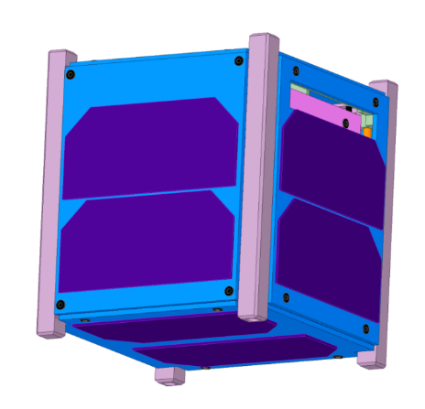
Solar Cell
Example
(Opposite side of Figure 3-1)
Z
X
Y
Figure 4-1-2 Overview of Satellite (Before Deployment)

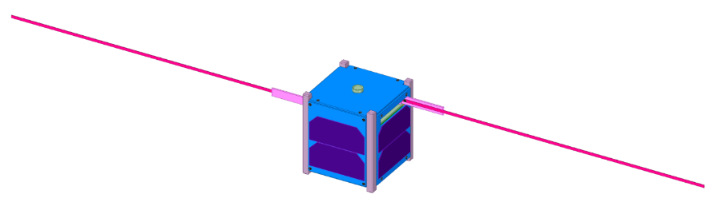
430mm
t = 0.3mm
4mm
Z
X
Y
Please add deployed image if satellite has deployment mechanism. Dimension of the deployed part must be added.
Antenna Cover
Figure 4-1-3 Overview of Satellite (After deployment)

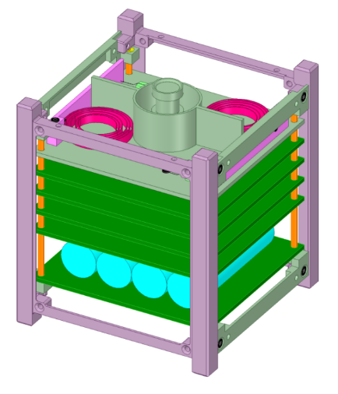
Antenna
Camera Guard
Spring hinge
Battery
Z
X
Y
Antenna Cover
Example
- This model is not simplified, but it shows all parts.
- Safety critical parts must be identified.
Figure 4-2-1 Overview of Satellite (internal)

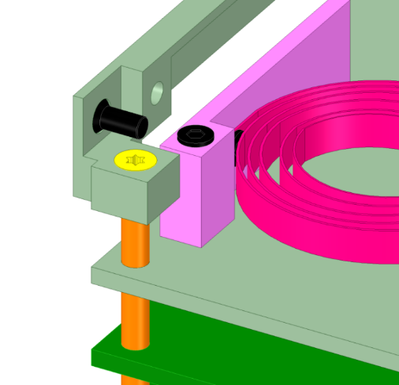
Antenna Cover
Antenna
Spring hinge
Stacking Rod
Please describe how each part is fixed to main structure if satellite has complicated fixing mechanism.
Main Structure
PCB
Figure 4-2-2 Overview of Satellite (detailed)

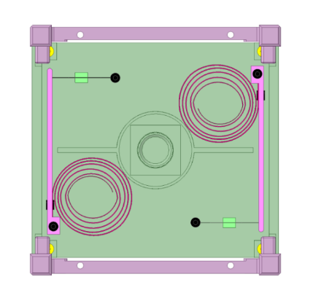
Antenna
Antenna Cover
Heat Cutter
Wire
Camera
Spring hinge
Please add how deployment mechanism is stowed if satellite has the mechanism. Wire, heat cutter and cover are shown in figure.
Figure 4-2-3 Overview of Satellite (stowed)

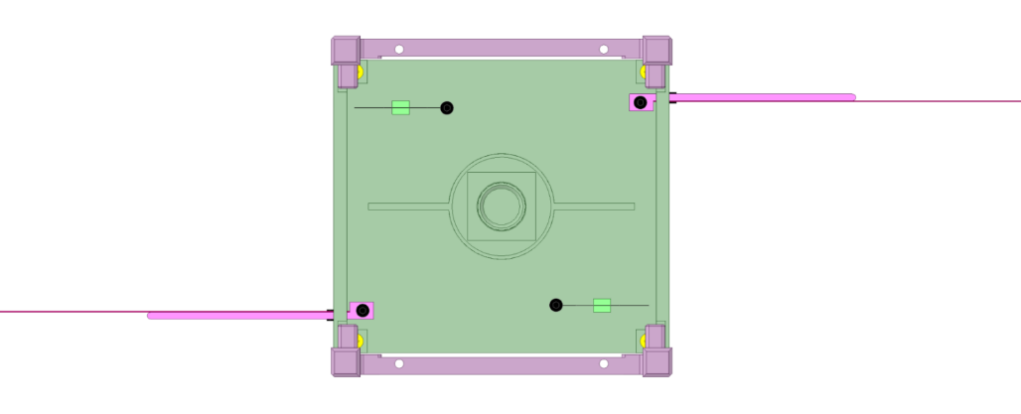
Antenna Cover
Wire
Camera
Heat Cutter
Antenna
Spring hinge
Please add deployed configuration if satellite has deployment mechanism.
Figure 4-2-4 Overview of Satellite (deployed)

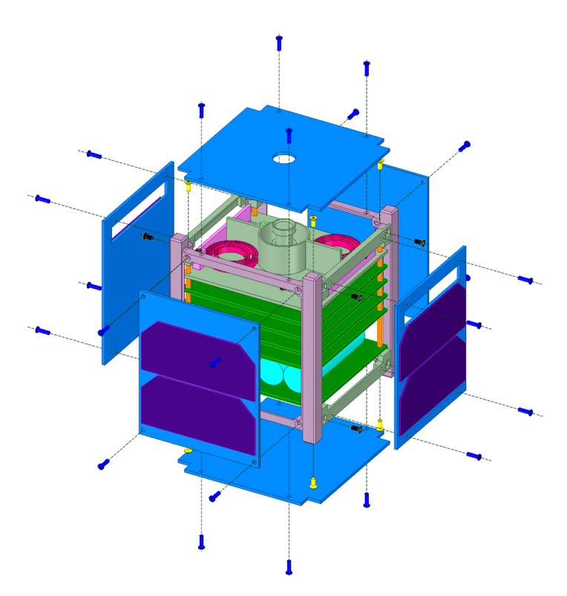

Z
X
Y

Example
-The numbers are corresponded to Table 3-1
Figure 4-3 Assembly Diagram
(Located on PCB)

Table 4-1 Parts list for structure analysis and fracture control
No | Part Name | Part No. | Material | Qty | In-house or Purchase | Remarks
1 | Minus_X panel | Minus_X panel | AL6061 | 1 | In-house
2 | Minus_Y panel | Minus_Y panel | AL6061 | 1 | In-house
3 | Minus_Z panel | Minus_Z panel | AL6061 | 1 | In-house
4 | Plus_X panel | Plus_X panel | AL6061 | 1 | In-house
5 | Plus_Y Panel | Plus_Y Panel | AL6061 | 1 | In-house
6 | Plus_Z panel | Plus_Z panel | AL6061 | 1 | In-house
7 | Structure Main Frame | Structure-01 | AL6061 | 1 | Purchase
8 | Fastener (Screw) | N/A | SUSXM7 | 40 | Purchase
9 | Stacking Rod | Rod | AL6061 | 4 | Purchase | All PCBs are fixed to these rods. The rods are fastened to Structure Main Frame.
10 | Solar Cell | Component-01 | Glass | 10 | Purchase | No cover films.
11 | Camera | Cam | Plastic/  Glass | 1 | Purchase | No cover films.
12 | Battery | Batt | Li-ion | 4 | Purchase
13 | Internal Components | N/A | - | - | In-house | Point mass to simulate the effect of internal components and the other miscellaneous items

Notice:
SFCB will confirm whether each safety critical part is contained in the satellite or not. Please fill Table 4-2. （SFCBは各セーフティークリティカルパーツが衛星にあるかどうかを確認します。下記のチェックリストを埋めてください。）

The critical part which identified on Table 4-2 is NOT shown in the figures above, please add the part in the figure. （もしチェックリストで識別された部品が本項の図に入っていない場合は、必ず書き加えてください。）
Table 4-2 Safety critical parts check list
No | Component | Qty | Covered?  (yes/no) | Remarks
1 | Camera lens (Grass) | 1 | No
2 | Solar Cell Cover Grass | 1 | No
3 | Other Grass Part | 0 | -
4 | Battery | 4 | Yes | Covered for electrical insulation
5 | Deployment Mechanism | 1 | Yes | - Antenna is covered by +Z panel  - Since thickness of the antenna is more than 1 mm, this mechanism is not hazard.
6 | Wire | 1 | - | Since the deployment mechanism is not hazard, the wire is not redundant.
7 | Rotating Device | 0 | - | *please describe if the motor is contained, and whether its energy is less than 14,240 ft-lbs or not.
8 | Pressure System | 0 | -
9 | Pressure Vessel | 0 | -

Analysis Model

Mass Characteristic
Location of the center of gravity is shown in Table 5.1-1. Coordinate system of J-SSOD satellite install case is used, and center of gravity is shown by coordinate which set satellite structure geometric center as origin.

Table 5.1-1 Center of Gravity
 | X axis [mm] | Y axis [mm] | Z axis [mm]
Center of gravity | 0.1117 | -0.181 | -5.9139
Requirement: The center gravity of satellite should fall within 20mm of the geometric center of CubeSat composed by 4 rails

Ballistic Number
Requirement: Ballistic Number (BN) shall be less than 100 kg/m². The BN is calculated using the equation below. The maximum BN for this satellite satisfies the requirement.

$$\text{Ballistic Number (}\text{BN}\text{)}=\frac{m}{C_{d}\text{∙}A}[kg/m^{2}]=XXX [kg/m^{2}]<100 [kg/m^{2}]$$

$C_{d}$ : the drag coefficient = 2
$A$ : minimum average projected area of satellite in XY, YZ, ZX (average of the smallest area and the 2nd smallest area of XY, YZ, ZX) = XXX m²
$m$ : maximum predicted satellite mass = 1.33 kg

Finite Element Modelling (FEM)
The Finite element model (Figure 5.3-1) of the structure was created by using XXXX software. The mass properties were used to construct a model with approximately equal mass as the components. The model was simplified as following steps;
- Only the components listed in Table 4-1 are modelled in the structure analysis.
- All internal components which does not located on the main load path are replaced with a simulated point mass inside the structure. This mass is located at the center of the satellite or at the center of simulated component. And the mass is connected to the main structure by same method as flight model.
- The mass of external components outside of main structure such as solar cells are added as simulated point mass to the screws which fastens the external components.
- A global bonded contact is used at thread face of fasteners to eliminate complexities created by screws and complex geometry. A frictionless sliding contact is used at the other boundary between each component.
- The structure is modified by removing fillets and holes to make meshing easier.
- Actual material properties are used for the materials.
- The axial load of fastener made by initial torque value is applied as tensile force at end face of each fastener. The axial load used in the analysis model is selected from Table 5.3-1.

Z
X
Y
Example
- A model used in FEA is shown.
- Coordinate system must be added
Figure 5.3-1 Finite element model

The axial load of fastener made by initial torque value is applied as tensile force
Figure 5.3-2 Input condition of axial load

Table 5.3-1 Axial load of fastener
Type | Nominal diameter [m] | Initial torque [Nm] | Axial load [N]
M1 | 0.001 | 0.0195 | 97.5
M1.2 | 0.0012 | 0.037 | 154.2
M1.6 | 0.0016 | 0.086 | 268.8
M2 | 0.002 | 0.176 | 440.0
M2.5 | 0.0025 | 0.36 | 720.0
M3 | 0.003 | 0.63 | 1050.0
M4 | 0.004 | 1.5 | 1875.0
M5 | 0.005 | 3 | 3000.0
M6 | 0.006 | 5.2 | 4333.3
M8 | 0.008 | 12.5 | 7812.5
M10 | 0.01 | 24.5 | 12250.0
M12 | 0.012 | 42 | 17500.0

Analysis Result

Natural Frequency Analysis
Analysis Condition:
Both ends of 4 rails are constrained rigidly based on Section 2.1.9 in applicable document (1).

FEM: Results
Analysis by XXXX software has revealed that minimum fundamental frequency is 448.4[Hz] which is much higher than 100[Hz].

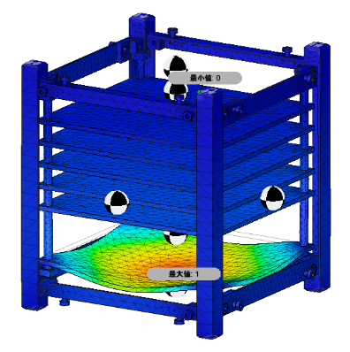
Z
X
Y
Example
Figure 6.1-1 Finite element model (1st Mode)

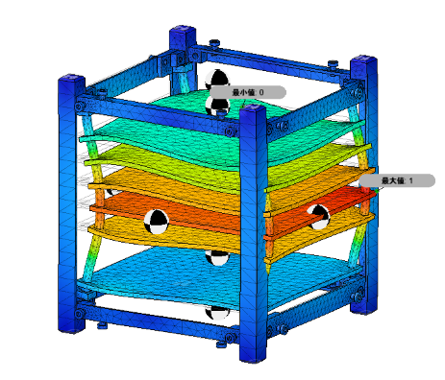
Z
X
Y
Example
Figure 6.1-2 Finite element model (2nd Mode)

Static Load Analysis
Analysis Condition:
Table 6.2-1 - Table 6.2-3 show condition for the analysis.

Table 6.2-1 Load Applied on FEM (Analysis A)
Load | X_axis | Y_axis | Z_axis
Compressive Load | - | - | 46.6 N
Static Load | 18.1G | - | -

Table 6.2-2 Load Applied on FEM (Analysis B)
Load | X_axis | Y_axis | Z_axis
Compressive Load | - | - | 46.6 N
Static Load | - | 18.1G | -

Table 6.2-3 Load Applied on FEM (Analysis C)
Load | X_axis | Y_axis | Z_axis
Compressive Load | - | - | 46.6 N
Static Load | - | - | 18.1G
- Using the quasi-static acceleration levels of Cygnus (18.1G), the model was subjected to static load of 18.1G (177.561 ms⁻²) in plane with the launch axis (1G = 9.81 ms⁻²).
- An axial force equal to 46.6N is applied on each rail
- Each rail is rigidly constrained at the base (- Z axis)

FEM: Results
The maximum von Mises stress on the satellite was 33.83 MPa, 31.28 MPa and 26.87 MPa in Analysis A, B and C respectively. Stress levels on various parts of the satellite are displayed in Table 6.2-4 - Table 6.2-6. And Figure 6.2-1 - Figure 6.2-3 show the FEM with input load, acceleration and constraint condition for each analysis cases. And the margin of safety for the various components was computed using a factor of safety of 1.5 for yield strength (Fty) and 2.0 for ultimate strength (Ftu). These values can include the factors of safety for Non-HTV and HTV.

$$\text{Margin of Safety (MS)}=\frac{\text{Allowable Stress}}{\text{Max stress (Smax) ×Factor of Safety(FS)}}-1≥0$$

The primary structure made of metallic materials and categorized as Low Risk Part must also satisfy the requirement given by the following equation:
Notice:
Non-metallic part must be categorized as Fracture Critical Part. （非金属の場合はフラクチャークリティカルパーツに識別するすること）
$$\frac{\text{Smax}}{\text{Ftu}}\text{<30\%}$$
Where Smax = maximum applied stress
Ftu = Ultimate Strength of the material

Table 6.2-4 Satellite Parts Stresses and Margin of Safety (Analysis A)
Part | Material | Max Stress (Smax) (MPa) | Yield Strength (MPa) | Ultimate Strength, Ftu(MPa) | MS^{*1} ≥1 (yield)  FS^{*2}=1.5 | MS^{*1} ≥1 (Ultimate)  FS^{*2}=2 | Smax/Ftu  <30[%]
Main structure Frame | Al 6061 | 33.83 | 275 | 310 | 4.41 | 3.58 | 10.9
Stacking Rod | Al 6061 | 30.63 | 275 | 310 | 4.98 | 4.06 | 9.8
*1:Margin of Safety, *2:Factor of Safety

Table 6.2-5 Satellite Parts Stresses and Margin of Safety (Analysis B)
Part | Material | Max Stress (Smax) (MPa) | Yield Strength (MPa) | Ultimate Strength, Ftu(MPa) | MS^{*1} ≥1 (yield)  FS^{*2}=1.5 | MS^{*1} ≥1 (Ultimate)  FS^{*2}=2 | Smax/Ftu  <30[%]
Main structure Frame | Al 6061 | 31.28 | 275 | 310 | 4.86 | 1.42 | 10.0
Stacking Rod | Al 6061 | 53.66 | XXX | XXX | 2.41 | 1.88 | 17.3
*1:Margin of Safety, *2:Factor of Safety

Table 6.2-6 Satellite Parts Stresses and Margin of Safety (Analysis C)
Part | Material | Max Stress (Smax) (MPa) | Yield Strength (MPa) | Ultimate Strength, Ftu(MPa) | MS^{*1} ≥1 (yield)  FS^{*2}=1.5 | MS^{*1} ≥1 (Ultimate)  FS^{*2}=2 | Smax/Ftu  <30[%]
Main structure Frame | Al 6061 | 26.87 | 275 | 310 | 5.82 | 4.76 | 8.6
Stacking Rod | Al 6061 | 24.99 | 275 | 310 | 6.33 | 5.20 | 8.0
*1:Margin of Safety, *2:Factor of Safety

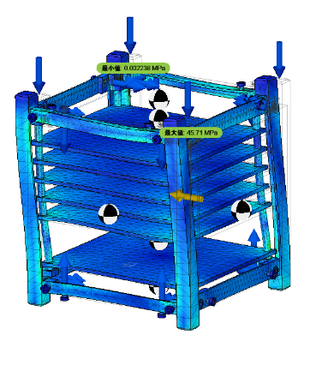
Z
X
Y
46.6N
at +Z face
18.1G
The axial load is added at the end face of each fastener
Constraint condition
at -Z face
Example
Figure 6.2-1 Result for Analysis A (X direction acceleration)

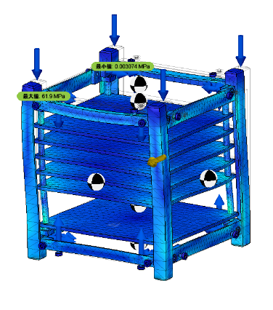
Z
X
Y
Example
Figure 6.2-2 Result for Analysis B (Y direction acceleration)

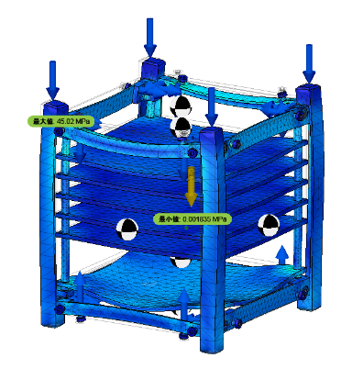
Z
X
Y
Example
Figure 6.2-3 Result for Analysis C (Z direction acceleration)

Bolt Analysis
The screws used in the structures are shown in Table 6.3-1. The stress at the joints are estimated from the CAD static analysis and the factor of safety is computed.

$$\text{Margin of Safety}\text{ (MS) }\text{=} \frac{\text{Allowable Stress}}{\text{Max Stress ×Factor of Safety}\text{(FS)}}\text{- }\text{1} \text{≥} \text{0}$$

Table 6.3-1 Screws in analysis model
No. | ID | Location | Type | Material | Initial Torque  [Nm] | Secondary Locking Feature
1-1 | ZP-1 | X+Y+ corner | M2.5x6 | SUSXM7 | 0.36 | Loctite243
1-2 | ZP-2 | X+Y- corner | M2.5x6 | SUSXM7 | 0.36 | Loctite243
1-3 | ZP-3 | X-Y+ corner | M2.5x6 | SUSXM7 | 0.36 | Loctite243
1-4 | ZP-4 | X-Y- corner | M2.5x6 | SUSXM7 | 0.36 | Loctite243
2-1 | ZM-1 | X+Y+ corner | M2.5x6 | SUSXM7 | 0.36 | Loctite243
2-2 | ZM-2 | X+Y- corner | M2.5x6 | SUSXM7 | 0.36 | Loctite243
2-3 | ZM-3 | X-Y+ corner | M2.5x6 | SUSXM7 | 0.36 | Loctite243
2-4 | ZM-4 | X-Y- corner | M2.5x6 | SUSXM7 | 0.36 | Loctite243
3-1 | XP-1 | Y+Z+ corner | M2.5x6 | SUSXM7 | 0.36 | Loctite243
3-2 | XP-2 | Y+Z- corner | M2.5x6 | SUSXM7 | 0.36 | Loctite243
3-3 | XP-3 | Y-Z+ corner | M2.5x6 | SUSXM7 | 0.36 | Loctite243
3-4 | XP-4 | Y-Z- corner | M2.5x6 | SUSXM7 | 0.36 | Loctite243
4-1 | XM-1 | Y+Z+ corner | M2.5x6 | SUSXM7 | 0.36 | Loctite243
4-2 | XM-2 | Y+Z- corner | M2.5x6 | SUSXM7 | 0.36 | Loctite243
4-3 | XM-3 | Y-Z+ corner | M2.5x6 | SUSXM7 | 0.36 | Loctite243
4-4 | XM-4 | Y-Z- corner | M2.5x6 | SUSXM7 | 0.36 | Loctite243
5-1 | YP-1 | Z+X+ corner | M2.5x6 | SUSXM7 | 0.36 | Loctite243
5-2 | YP-2 | Z+X- corner | M2.5x6 | SUSXM7 | 0.36 | Loctite243
5-3 | YP-3 | Z-X+ corner | M2.5x6 | SUSXM7 | 0.36 | Loctite243
5-4 | YP-4 | Z-X- corner | M2.5x6 | SUSXM7 | 0.36 | Loctite243
6-1 | YM-1 | Z+X+ corner | M2.5x6 | SUSXM7 | 0.36 | Loctite243
6-2 | YM-2 | Z+X- corner | M2.5x6 | SUSXM7 | 0.36 | Loctite243
6-3 | YM-3 | Z-X+ corner | M2.5x6 | SUSXM7 | 0.36 | Loctite243
6-4 | YM-4 | Z-X- corner | M2.5x6 | SUSXM7 | 0.36 | Loctite243
7-1 | MS-1 | X+panel Z+Y+ corner | M2.5x6 | SUSXM7 | 0.36 | Loctite243
7-2 | MS-2 | X+panel Z+Y- corner | M2.5x6 | SUSXM7 | 0.36 | Loctite243
7-3 | MS-3 | X+panel Z-Y+ corner | M2.5x6 | SUSXM7 | 0.36 | Loctite243
7-4 | MS-4 | X+panel Z-Y- corner | M2.5x6 | SUSXM7 | 0.36 | Loctite243
7-5 | MS-5 | X-panel X+Y+ corner | M2.5x6 | SUSXM7 | 0.36 | Loctite243
7-6 | MS-6 | X-panel X+Y- corner | M2.5x6 | SUSXM7 | 0.36 | Loctite243
7-7 | MS-7 | X-panel X-Y+ corner | M2.5x6 | SUSXM7 | 0.36 | Loctite243
7-8 | MS-8 | Z-panel X-Y- corner | M2.5x6 | SUSXM7 | 0.36 | Loctite243

Table 6.3-2 Bolt Analysis Result for Nominal Case
No. | Case | Max Stress [MPa] | Ultimate Strength [MPa] | MS^{*1} ≥1  (FS^{*2}=2) | Screw ID with  Max Stress  (Ref. Table5.3-1)
1 | Analysis A | 45.71 | 450 | 3.92 | XP-3
2 | Analysis B | 61.9 | 450 | 2.63 | XM-3
3 | Analysis C | 45.02 | 450 | 3.99 | XM-3
*1:Margin of Safety, *2:Factor of Safety

Structure Fracture Control

Potentially Fracture Critical Parts Identification
Screening of safety critical structures and fracture control classification are performed in accordance with JMX-2011303E. Safety critical structures is summarized in Table 7.1-1. As shown in this table, low risk fracture parts, contained parts, and fail-safe parts are identified.

Contained Parts
All internal parts are classified as contained parts since they are contained by the most-outer structures made of aluminum alloy with sufficiently small gaps.

Fail-Safe Parts
All fasteners were locked using liquid-locking compound. After the vibration test, all fastener with torque mark will be inspected visually.

Low Risk Fracture Parts
Low risk fracture parts are listed in Table 7.1-2.
All low risk parts will be conducted visual inspection at least before assembly and after vibration test. Since the deployable mechanism is not identified as hazard in Safety Assessment Report, the wire which fastens deployable mechanism is not classified as low risk fracture part.
(The results will be included in Vibration test report)
*Refer: SSP52005F/5.3.1.4.2.1/C

Sealed Container
There is no sealed container in this satellite.

Fracture Critical Parts
Glasses for solar cells and camera lens are classified as fracture critical parts. Since the outer panels are made of metallic material, they are not classified as fracture critical part.
As fracture control of these glass parts, vibration test at flight level will be performed.
(The results will be included in vibration test report)

Pressurized System
There is no pressure system in this satellite.

Pressure Vessel
There is no pressure vessel in this satellite.

High-Energy Rotating Machineries
There is no rotating machinery in this satellite.

Inspection for Safety Critical Structures
It will be confirmed that there is no non-conformance in the safety critical structures as a result of the inspection from the part acceptance phase through whole the assembly phase in accordance with JMX-2011303E.

Inspection after Tests
After vibration test, it will be confirmed that there is no non-conformance in the safety critical structures as a result of the inspection in accordance with JMX-2011303E.

Discrepancy or Anomaly Reports
No discrepancy or anomaly was identified.

Material Usage Agreements for Stress Corrosion Cracking Material
There is no MUA.

Conclusions
The structural analysis of is completed.
All parts met the fracture control requirements to ensure no failures occur throughout the life due to fracture.
Table 7.1-1: Potentially Fracture Critical Parts Identification List
No | Part Name | Part No. | Material | Function | Failure Mode | Effect of Failure*1 | Low Risk Fracture Part | Contained Part | Fail Safe Part | Fracture Critical part | Remarks
1 | Minus_X panel | Minus_X panel | AL6061 | structure | tensile  bending | 7 | - | - | - | × | Verified with structural Analysis
2 | Minus_Y panel | Minus_Y panel | AL6061 | structure | tensile  bending | 7 | - | - | - | × | Verified with structural Analysis
3 | Minus_Z panel | Minus_Z panel | AL6061 | structure | tensile  bending | 7 | - | - | - | × | Verified with structural Analysis
4 | Plus_X panel | Plus_X panel | AL6061 | structure | tensile  bending | 7 | - | - | - | × | Verified with structural Analysis
5 | Plus_Y Panel | Plus_Y Panel | AL6061 | structure | tensile  bending | 7 | - | - | - | × | Verified with structural Analysis
6 | Plus_Z panel | Plus_Z panel | AL6061 | structure | tensile  bending | 7 | - | - | - | × | Verified with structural Analysis
7 | Structure  Main Frame | Structure-01 | AL6061 | structure | tensile  bending | 7 | × | - | - | - | Verified with structural Analysis
8 | Fastener (Screw) | N/A | SUSXM7 | structure | tensile  shear | 7 | - | - | × | - | Verified with structural Analysis
9 | Stacking Rod | Rod | AL6061 | structure | tensile  bending | 7 | - | × | - | - | Verified with structural Analysis
10 | Solar Cell | Component-01 | Glass | mission | breakage | 2 | - | - | - | × | No cover films.  Verified with Vibration test at flight level
11 | Camera | Cam | Plastic/  Glass | mission | breakage | 2 | - | - | - | × | No cover films.  Verified with Vibration test at flight level
12 | Battery | Batt | Li-ion | mission | breakage | 2 | - | × | - | - | Verified with Vibration test at flight level
13 | Internal Components | - | - | mission | - | - | - | × | - | - | Verified with Vibration test at flight level
*1: Effect of failure is specified from the number listed below.
1. Hazardous to personnel 2. Hazardous to Flight Crew 3. Hazardous to GSE 4. Hazardous to J-SSOD
5. Hazardous to HTV 6. Hazardous to JEM 7. Hazardous to ISS

