***\*Notice:***

***This file is an example based on generic satellite design and does not guarantee to be approved on the review process for launch or deployment. In accordance with design of each satellite, this document may have to be changed. Details of this template are subject to change without notice. Please change YELLOW sentence according to each satellite.***

***(本文書は標準的な設計の衛星を想定した一例であり、打上げ・放出のための審査プロセスでの承認を保証しているものではありません。各衛星の設計によって内容を変更する必要があります。また、本テンプレートの内容は予告なく変更される場合があります。黄色の箇所を各衛星に応じて変更してください。)***

[Satellite Name]

Sharp Edge Inspection Report

Initial Release: DD/MM/YYYY

[Project Team Name]

Revision History

|  |  |  |  |
| --- | --- | --- | --- |
| Version | Date | Writer | Annotations |
| 1 | DD/MM/YYYY | XXX | Initial Release |
| 1.1 |  |  |  |
| 1.2 |  |  |  |
|  |  |  |  |
|  |  |  |  |
|  |  |  |  |

Contents

**1.** **Purpose** 1

**2.** **Applicable Document** 1

**3.** **Inspection method** 1

**4.** **Inspection result** 1

**5.** **Conclusion** 3

# **Purpose**

This document summarizes the result of sharp edge inspection for [Satellite Name] which will be deployed from JEM Small Satellites Orbital Deployer (J-SSOD).

# **Applicable Document**

1. JX-ESPC-101132-C JEM Payload Accommodation Handbook-Vol.8-

Small Satellite Deployment Interface Control Document

1. [Document Number] [Satellite Name] Flight Safety Assessment Report

for phase XXX

# **Inspection method**

The satellite was inspected by touching the surface of the satellite at several points to confirm there is no sharp edge. The satellite was also inspected by observing the external appearance.

# **Inspection result**

Date of inspection：[YYYY/MM/DD]

Place of inspection：[XXXX]

[SAMPLE]

Please change an actual photo



A

C

C

C

C

B

B

B

B

Figure 4-1.　 Photo of +Z surface (deployment direction)

[SAMPLE]

Please change an actual photo

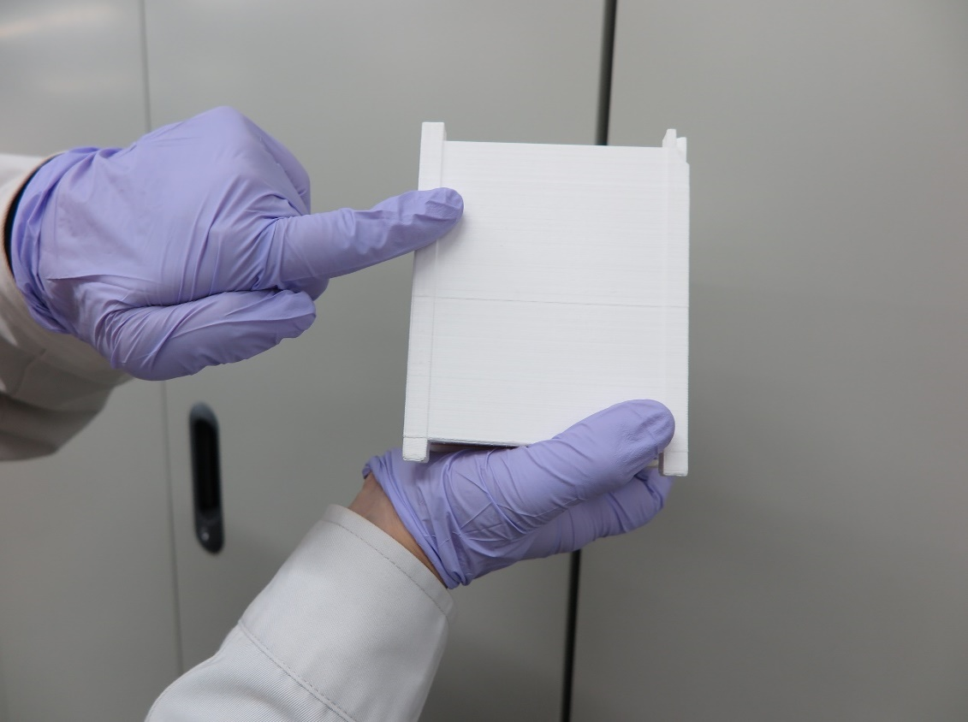

Figure 4-2. Satellite Sharp Edge Touching Inspection (+Z panel)

[SAMPLE]

Please change an actual photo

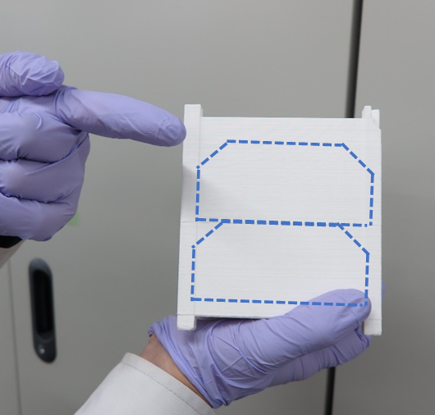

No scratch

Figure 4-3. After Satellite Sharp Edge Touching Inspection

# **Conclusion**

No sharp edge on the satellite body was detected by visual and touch inspections.