*Notice:
This file is an example based on generic satellite design and does not guarantee to be approved on the review process for launch or deployment. In accordance with design of each satellite, this document may have to be changed. Details of this template are subject to change without notice. Please change YELLOW sentence according to each satellite.
(本文書は標準的な設計の衛星を想定した一例であり、打上げ・放出のための審査プロセスでの承認を保証しているものではありません。各衛星の設計によって内容を変更する必要があります。また、本テンプレートの内容は予告なく変更される場合があります。黄色の箇所を各衛星に応じて変更してください。)

[Satellite Name]
Inhibit Function Test Report

Initial Release: DD/MM/YYYY

[Project Team Name]

Revision History

Version | Date | Writer | Annotations
1 | DD/MM/YYYY | XXX | Initial Release
1.1
1.2

Contents
1 Purpose 1
2 Applicable Document 1
3 Design for the inhibit on Safety Circuit 1
4 Test Method 2
4.1 Deployment Switch 2
4.1.1 Function Test 2
4.1.2 Inspection 2
4.2 Double Insulation 3
5 Test Results 3
5.1 Deployment Switch 3
5.1.1 Function Test 3
5.1.2 Inspection 5
5.2 Double Insulation 5
6 Conclusion 6

Purpose
This document summarizes the results of inhibit function test for [Satellite Name] which will be deployed from JEM Small Satellites Orbital Deployer (J-SSOD).
Notice:
This document is an example of inhibit function test for battery hazard. If a satellite has other hazards such as deployable mechanism or RF transmission, an additional test may be required. （本文書はバッテリーハザードの安全制御機能試験を想定した一例です。もし、衛星が展開構造や無線放射といった他のハザードを有する場合は、追加の検証が必要となる可能性があります。）

Applicable Document
- JX-ESPC-101132-C JEM Payload Accommodation Handbook-Vol.8-
Small Satellite Deployment Interface Control Document

- [Document Number] [Satellite Name] Flight Safety Assessment Report
for phase XXX

Design for the inhibit on Safety Circuit
Circuit Description and Electrical Schematic is shown on Figure 3-1. Electric power system (EPS) in the satellite also has protection devices from over charge, over discharge and external short.

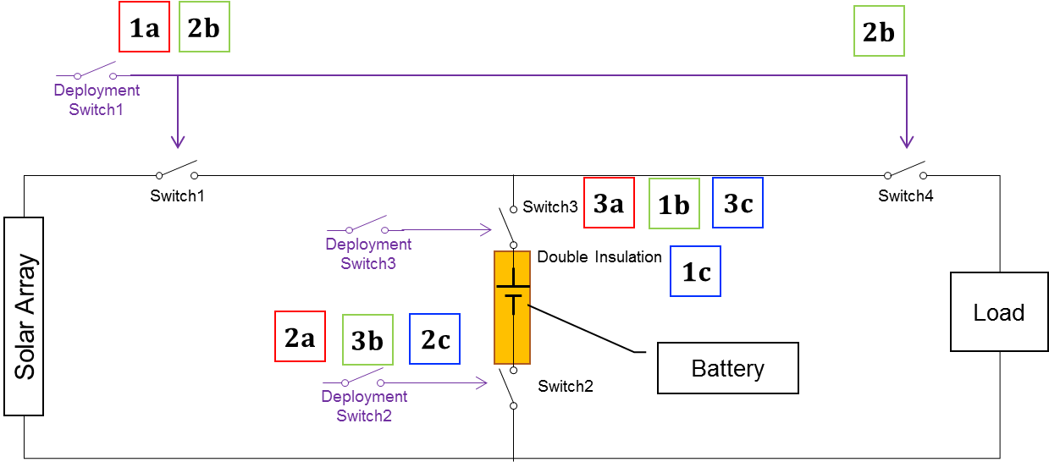
Example
 | Inhibit 1 | Inhibit 2 | Inhibit 3
Over-Charge [a] | Deployment SW#1 | Deployment SW#2 | Deployment SW#3
Over-Discharge [b] | Deployment SW#3 | Deployment SW#1 | Deployment SW#2
External Short [c] | Double Insulation | Deployment SW#2 | Deployment SW#3

Figure 3-1 Schematic for the inhibit on Safety Circuit

Test Method

Deployment Switch

Function Test
The whole satellite system is used for this test. The deployment switches are pushed before deployment and released after deployment. Therefore, the satellite is verified if the power system of the satellite is turned off when the deployment switches are pushed. Test procedure is as follows.

- The battery is charged until at least above minimum voltage for activating the satellite.
- Monitor voltage at downstream of the deployment switches. Current is also monitored if possible.
- If supply voltage of the solar panel is unstable, a standard power supply is used.
- Each deployment switch is pushed. And verify that voltage and current become zero. Note that each deployment switch is verified separately.

Please add the schematic of test
- Include voltage/current measurement points
- Include positions of deployment switches
- Include power line between solar panel, battery and loads.

Figure 4.1.1-1 Test configuration for deployment switch

Inspection
The stroke of the deployment switch shall be less than 2.0 mm from the surface of the rail standoffs as shown in the Figure 4.1.2-1. And the force generated by a deployment switch shall be no greater than 3N for each. The stroke and force are measured.

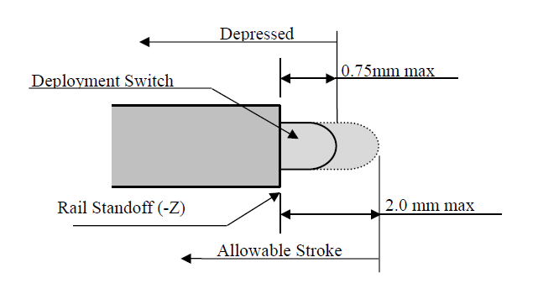
Figure 4.1.2-1 Depressed Condition and Allowable Stroke of Deployment Switches

Double Insulation
The related PCBs (Printed Circuit Board), which includes at least battery, the nearest deployment switches and lines between the battery and the switches, are used for this test. Note that the tested PCBs and lines can not be changed after this test. Test procedure is as follows.

- Inspect visually double insulated area. Take photo of inspected area.
- Measure resistance at outside surface of double insulators between hot line and ground line of the battery.

Test Results

Date of test: [YYYY/MM/DD]
Place of test: [XXXX]

Deployment Switch

Function Test
When each deployment switch was pushed separately, the power system of the satellite was turned off. The test results are shown in Figure 5.1.1-1 – Figure 5.1.1-3.

Please include the measurements voltage graph with inhibit status

Figure 5.1.1-1 Measurements voltage with inhibit status
(Dep.S/W#1: pushed, Other Dep.S/Ws: released)

Please include the measurements voltage graph with inhibit status

Figure 5.1.1-2 Measurements voltage with inhibit status
(Dep.S/W#2: pushed, Other Dep.S/Ws: released)

Please include the measurements voltage graph with inhibit status

Figure 5.1.1-3 Measurements voltage with inhibit status
(Dep.S/W#3: pushed, Other Dep.S/Ws: released)

Inspection
The result is shown in Fiure 5.1.2-1 and Figure 5.1.2-2.

Table 5.1.2-1 Test Result (Stroke)
 |  | Stroke [mm]
 |  | Pressed ≦ 0.75 mm | Depressed ≦ 2 mm
1 | Deployment SW#1
2 | Deployment SW#2
3 | Deployment SW#3

Table 5.1.2-2 Test Result (Force)
 |  | Force ≦ 3 [N]
1 | Deployment SW#1
2 | Deployment SW#2
3 | Deployment SW#3

Double Insulation
No damage or scratch on the insulated surface was found. And the measurement of resistance resulted that all hot and return pins of the battery were insulated. The result is shown in Table 5.2-1 and Figure 5.2-1.

Table 5.2-1 Test Result
No. | Measurement point |  | Resistance [Ω]
1
2
3
4

Please include a photo of double insulation

Figure 5.2-1 Inspection of Double Insulation

Conclusion
According to the results of the measurements, we confirmed that [Satellite Name] has appropriate inhibit function.

